RESUME

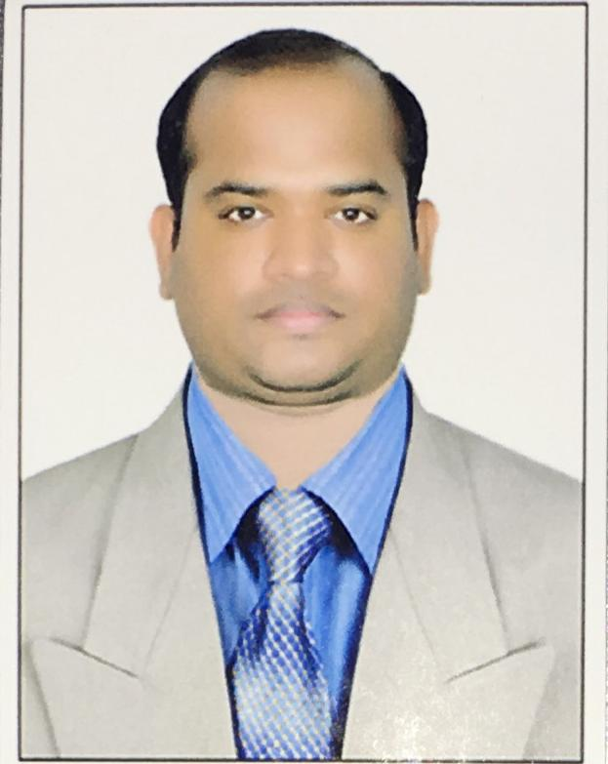
RAJESH KUMAR NATH
Mobile: 91-6361846386 e-mail : rajeshnathkumar16@gmail.com & rajeshnathkumar@yahoo.com
Present Address- Sahakar Nagar Post Bengaluru-560092, India.

Experience Summary

Working in Retail Sector past 16.09 years from Various Organization.

ABROAD EXPERIENCE SUMMARY:

- 3.7 Years Oct 2014 to May 2018 worked in REDTAG(KSA) as a Store Manager & Cluster Manager Handled 4 stores about 72k SQFT. 4SM-3ASM-16 Supervisor & 145 staff were reporting to me.
INDIA EXPERIENCE SUMMARY:

- From Feb 2023 till date working with Reliance Retail in Hyderabad (Smart Bazaar & Smart) as a Market Manager. Taking care of 5 stores which is around 300k SQFT. Annual turnover of 200-250CR.

- From Jan 2020 to Nov 2022 Worked in Spar Hypermarket in Bangalore as an Sr Store Manager. Was Taking care of 2 stores which is around 120k SQFT. Annual turnover of 140CR.

- From July 2018 to Dec 2020 worked with Bigbazaar Hyderabad as a General Manager. Was taking care of one of the high throughput store.

- 3.10 Years Nov 2010 to Sept 2014 worked in TATA Croma in Bangalore as an ADM & Deputy Manager for 20k Sqft store.

- 4.2 Years Aug 2006 to Oct 2010 Worked in Shopperstop in Bangalore as a CSA & Sr CSA & T

ACADEMIC CHRONICLE:
Course | Name Of The Institute | University /Board | Year Of Passing
BCA | DR CV RAMAN UNIVERSITY | DR CV RAMAN UNIVERSITY BILASPUR | JUNE-2013
+2 SCIENCE | Aul collage, Aul | Council Of Higher Secondary Education Orissa, Bhubaneswar | MAY-2006
SSC. | Damodar High School, Ayatpur | Board of Secondary Education,  Orissa | March 2004

Job Responsibilities of Retail operations:

- Merchandising handling
A-Making sure correct receipt the stock at the store from W/H
B-Merchandise Replenishment & Inventory reordering
C-Follow Write of procedure

2-Customer Service & Loyalty Programs
A-All the customers are enrolled
B-Go beyond transactional Rewards
C-Often calling 3* & 5* customer & Update The promotion details.

3-Visual Merchandising
A-Store window display to be updated as per current theme
B-Capture Data to enable the productivity of the Product displayed
C-Examine the display from customer point of view

4-Schemes
A-Current offer executed properly
B-Stocks are available of the current offer
C- Feedback from customer of the current offer

5-Report Making
A-All the store Reports are correctly maintained
B-Based on the report Take an action
C-Follow up on the same

6-Performance management
A-Set a goal to each and every staff
B-Train & Develop
C-Succession planning
D- Reward management
E-Job Analysis
F-Skill Set

7-People management
A-Outline the goals
B-Determine where we can improve
C-Talk to team
D-Get Organized
E-Parroting & Paraphrasing
F-Praising & Rewarding

8-Training
A-Training to be completed in all the aspect to all the staff
B-Feedback & Exam to be conducted after training.
C-Implementing the same in Job
D-Continuous feedback

9-Marketing
A-Figure out the targeted customer
B-Describe them our product
C-Pricing, positioning & Branding

10-P&L
A-Making sure my Opex in control
B-Save maximum to achieve bottom line.
C-Effective use of companys Devices

Significant Achievement:

- Got Employee of the month in Shoppers stop for 5 times being consistent in my job role.

- In the month of OCT 2011 achieved the ever-highest sale in TATA Croma of 178% breaking all the previous record.

- In RED TAG brought 4 Stores from -14% to +ve 5%

- In Reliance Bringing all the stores to positive EBITA .

Strengths:

- Self-Motivator.
- Time management.
- Good team player.
- Can do it,

Hobbies:

- Listing Music & Watching Motivational Videos.
- Accepting New market Trends
- Always learn new things

Personal Details:

Name: Rajesh Kumar nath

Father's name: Pabitra Mohan Nath
Date of birth: 01 Jan 1988.
Gender: Male.
Marital status: Married.
Languages known: To Read and Write: English, Hindi & Oriya.
To Speak: English, Hindi, Kanada , Arabic,Tamil & Oriya.
Nationality: India.
Religion: Hindu.

Permanent Address: At/Po- Bhuinpur, Police Station-Aul, Dist-
Kendrapara, Pin-754239, State- Odisha.

Passport Details:

Passport No: N9752419
Date of Expiry: 12-09-2026.

Declaration:

I hereby declare that above information is true to the best of my knowledge and belief.

Place : Bangalore Yours Faith Fully
Date : Rajesh

